1. f(x) = 2x3 – 11.7x2 + 17.7x – 5

Root: .365

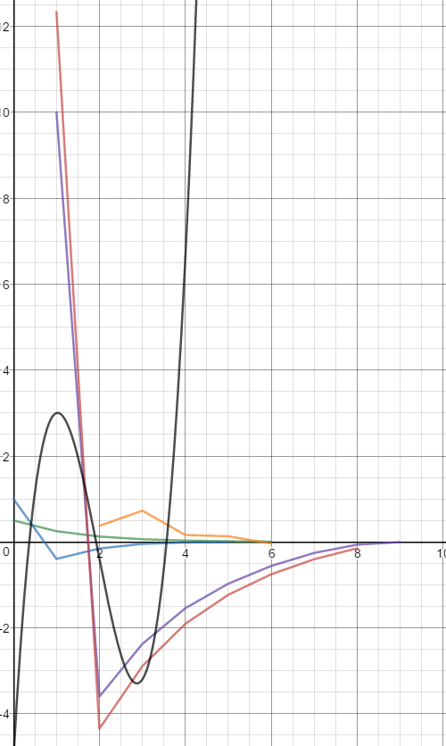

Green: Bisection Method Initial: a=0, b=1

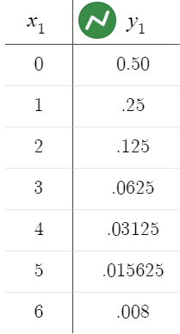

Blue: False-Position Method initial: a=0, b=1

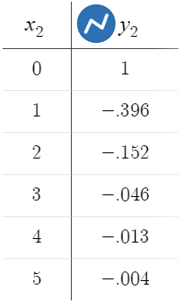

Purple: Newton-Raphson Method Initial x = 1

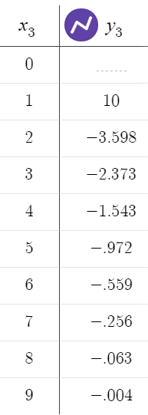

Orange: Secant Method Initial: a=0, b=1

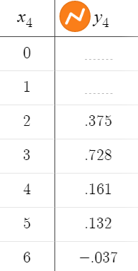

Red: Modified Secant Method Initial: x = 1, delta = .01

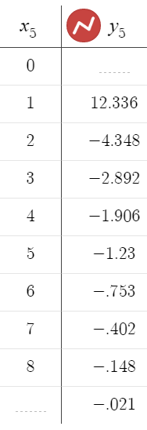

Root: 1.922

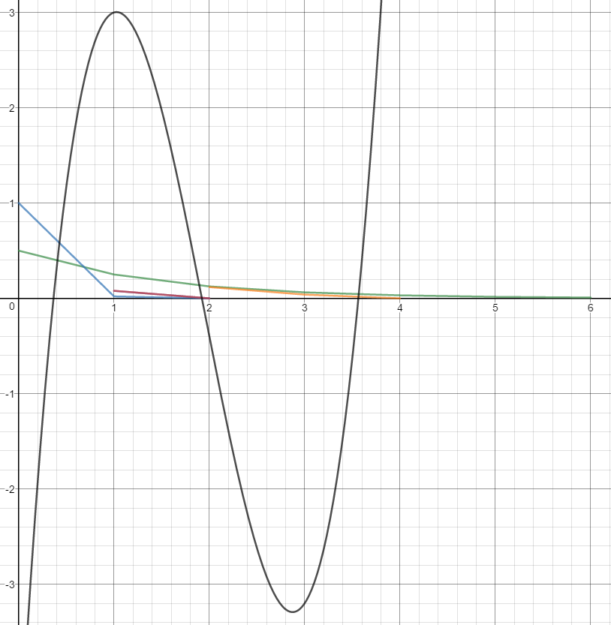

Green: Bisection Method Initial: a=1, b=2

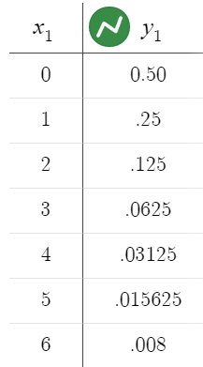

Blue: False-Position Method initial: a=1, b=2

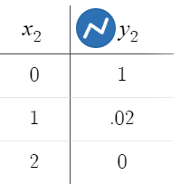

Purple: Newton-Raphson Method Initial x = 2

(Not very visible because similar graph as Modsec)

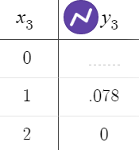

Orange: Secant Method Initial: a=1, b=2

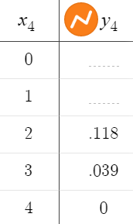

Red: Modified Secant Method Initial: x = 2, delta = .01

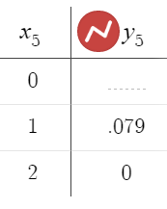

Root: 3.563

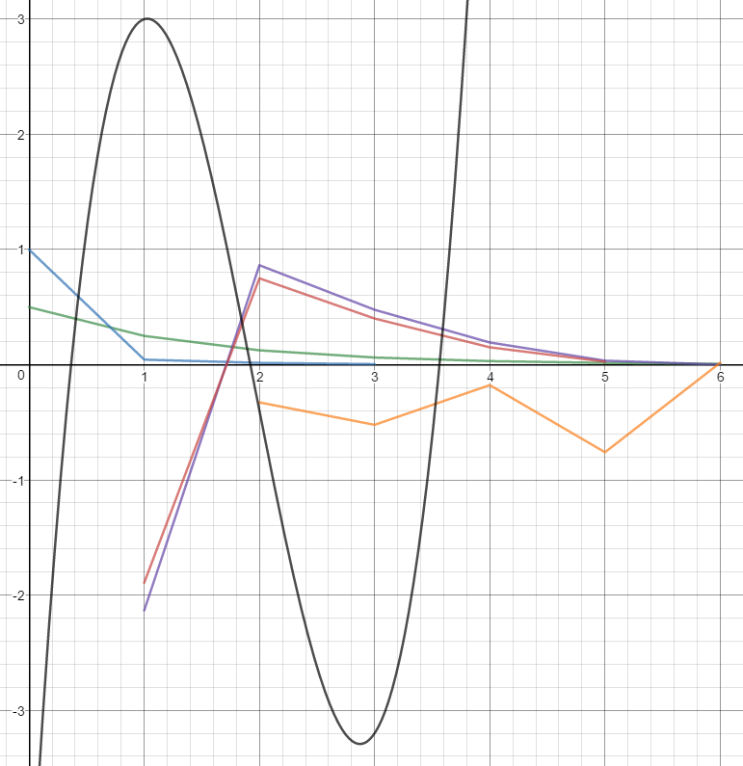

Green: Bisection Method Initial: a=3, b=4

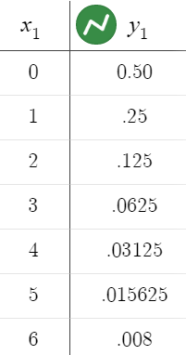

Blue: False-Position Method initial: a=3, b=4

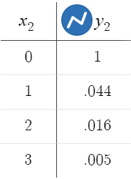

Purple: Newton-Raphson Method Initial x = 3

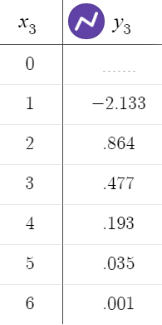

Orange: Secant Method Initial: a=3, b=4

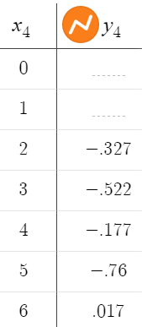

Red: Modified Secant Method Initial: x = 3, delta = .01

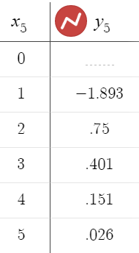

b) e-x -x

Root: 0.56714329

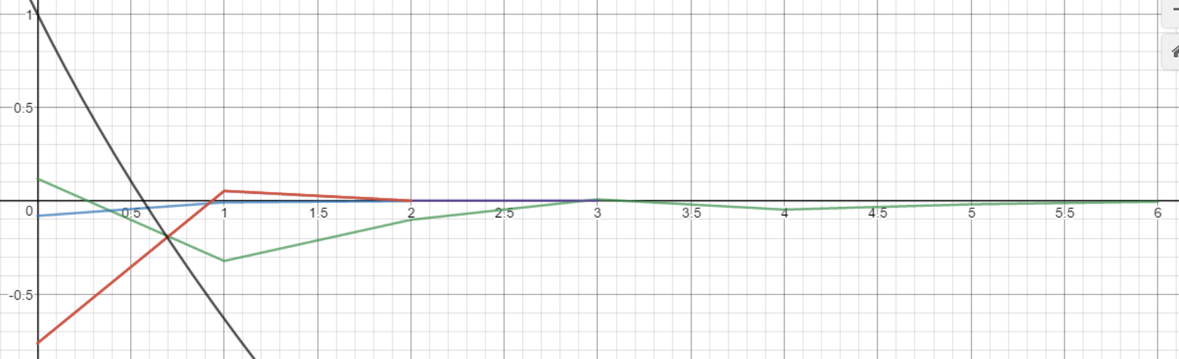

Green: Bisection Method Initial: a=0, b=1

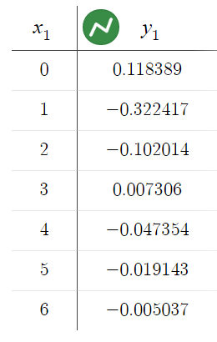

Blue: False-Position Method initial: a=0, b=1

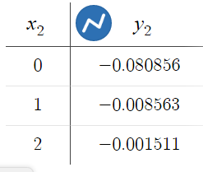

Purple: Newton-Raphson Method Initial x = 1

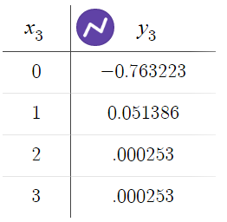

Orange: Secant Method Initial: a=0, b=1

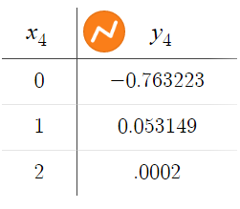

Red: Modified Secant Method Initial: x = 1, delta = .01

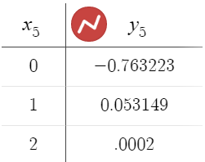

(Practically the same graph as secant method)

Graph URLs

Function 1 Root .365:

<https://www.desmos.com/calculator/szwjsj4lx7>

Function 1 Root 1.922:

<https://www.desmos.com/calculator/2klez9ui5h>

Function 1 Root 3.563:

<https://www.desmos.com/calculator/hry3o9zmpy>

Function 2 Root 0.56714329:

<https://www.desmos.com/calculator/tuywwbsuri>